**MIND STORM SOFTWARE PVT LTD**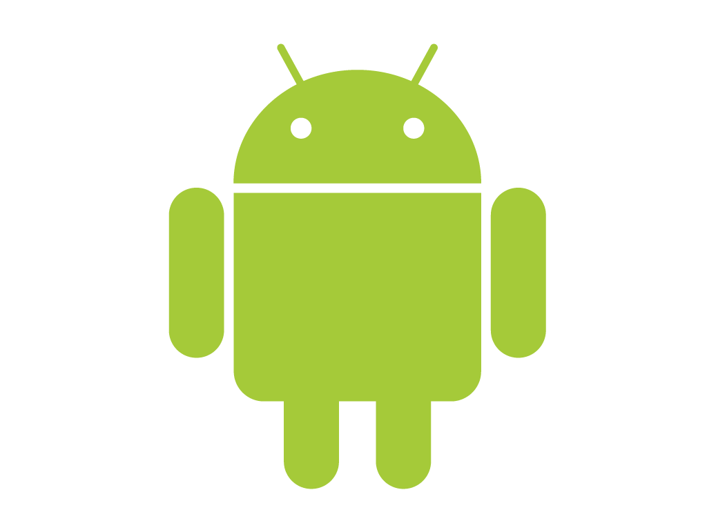  
**Android Development Training**

**Hands-On Exercise – APK Creation.docx**

**Objective**This exercise demonstrates how to generate the APK file that you need to distribute to the marketplace so that users can install your application. This is equivalent to creating an installation file for your application.

**Assumptions**

* Development Environment for Android (Java SDK, Eclipse, Android SDK) has been setup successfully.
* You are familiar with using Eclipse.
* You have an available Android project that you want to create an installation file (.APK) for. We shall assume **ex02** Project. **You can select any project you want but for our discussion, we will go with the ex02 name.**

**Step by Step Instructions**

1. Open the **ex02** project in Eclipse.
2. Right-click the Project. Select **Android Tools 🡪 Export Signed Application Package**
3. This will display the screen as shown below:

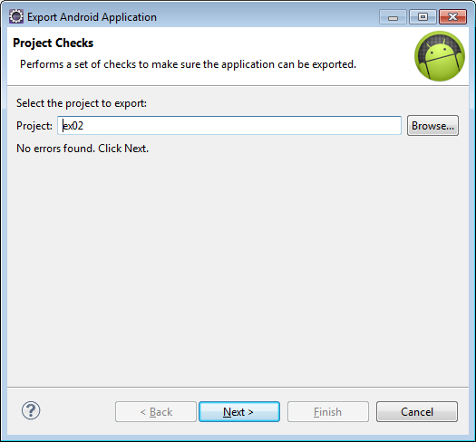

1. In the Keystore selection dialog, select **Create new keystore (**on all subsequent signing you can use the same keystore that you generate at the end of this hands-on exercise) and fill up appropriate values as shown below:

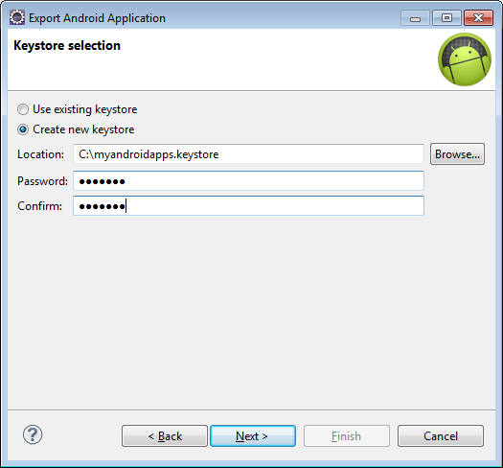  
  
The **Location** is any place on your machine and give a filename of your choice. Select a **password** too (I have selected android). Click on **Next** to move forward.

1. The next step involves providing details about your key. Fill in the values as shown below:

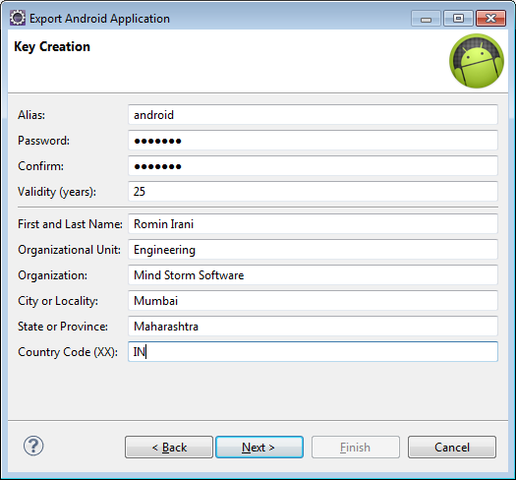

You can give any alias for the key. Think of an alias a keyname. Select as password and validity for your key. And fill out the other details as given below. These details are necessary so as to identify the entity that is signing the Android Application Package. Click on **Next** to continue.

1. The final step involves selecting a path for your APK file. Provide a path. A sample is shown below:

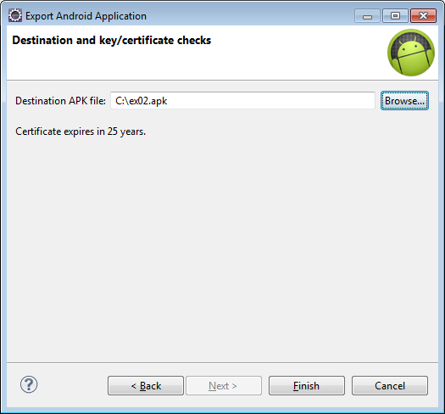  
  
Click on **Finish**.

1. This generates the .APK file that you can then use to upload and distribute via the Marketplace.

**Summary**

This exercise demonstrated how to package your application for distribution via the Marketplace. Even if you are not distributing your application via the marketplace, you will need to still package it as a .APK file.

**Note:** *To install non marketplace applications on the device, the user will need to go into Settings 🡪 Applications and* ***select*** *“Unknown sources” to allow installation on non-Market applications.*